**Rose Ann’s**

**Review**

**Delta Kappa Gamma**

**Theta Chapter**

**November, 2018**



**Pennsylvania State Convention**

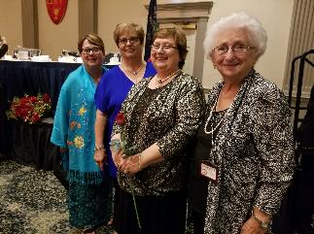

I am honored to be your President for a second

Biennium. I will always represent our chapter with pride and dignity.

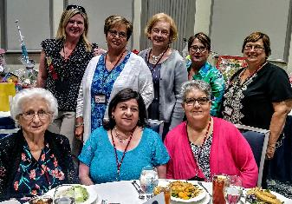

Thank You for attending the State Luncheon!

Tabitha Geramita, Sharon Schurman,Madeline

Carson, Linda Konzal Evans, Rose Ann Colosimo,

Marianne Graczyk, Terri Magnotta, Pat Zinger

**Power Wrap**

Thank You to everyone who donated

to make the Holidays special for the

women at the Power House. We will

continue wrapping and filling bags on

December 10 at the Word of God

School, from 9:00 AM to 1:00PM.

Your help will be greatly appreciated.

Welcome to our new member Tammy

Schmidt. At Tammy’s induction she

will receive Dr. Patricia Kupec’s DKG

pin. Dr. Kupec spent almost her

entire career at Beechwood

Elementary School where Tammy is

currently teaching. Tammy wasn’t at

Beechwood during Pat’s career

however, they met each other

through mutual friends a few

years ago. It is significant that

Tammy will proudly wear Pat’s pin.



P1

P.1

P1

**P****urposeful Seminar**

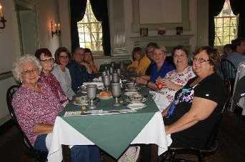

Marianne Graczyk and Rose Ann Colosimo

enjoyed enhancing their knowledge regarding

women during the Revolutionary War.

**What Makes Teaching So Worthwhile!**

An Icelandic student I taught at Greenfield School in 1989 recently visited me. He had come to America with his parents speaking no English until they found the ESL program at Greenfield. He and his parents credit me and the ESL program with changing Stefán Svavarsson’s life. He is now a history teacher and tour guide in Iceland, still speaking perfect English, after one year in America.

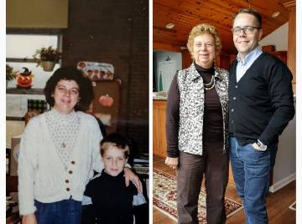

Deb Beozzo and Stefán Svavarsson

1989 & 2018

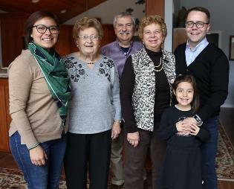

**Celebrating the Success**

**of Teaching!**

Svavarsson family with Sye & Deb Beozzo, and Rosemary Hulsman



**Important Dates to Remember**

**Shannopin Country Club Holiday Social:**

December 8, 2018

**PFT Helping Hands for the Benefit:**

February 21, 2019

**Creative Arts Retreat:** March 28-30, 2019

**Nevillewood Country Club, Benefit:**

**GAMES PEOPLE PLAY!**

Saturday, April 6, 2019

**Founders Day: South Hills Country Club:**

May 18, 2019

**Pensylvania State Convention:** June 14,15,16, 2019 Nittany Lion Inn State College, PA

**Northeast Regional Conference, Mashantucket, CT:** July 30- August 1, 2019