**Rose Ann’s**

**Review**

**Delta Kappa Gamma**

**Theta Chapter**

**January 15, 2019**



**Power Wrap**

Thank You to everyone who donated

to make the Holidays special for the

women at the POWER House.

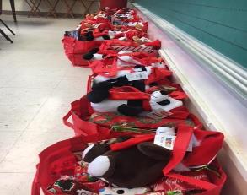

POWER Wrap at Word of God School in

December.

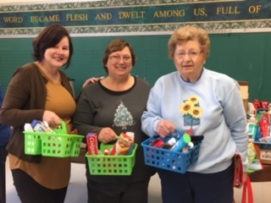

Kathy Reim, Rose Ann Colosimo and

Rosemary Hulsman filling Shower Caddies.

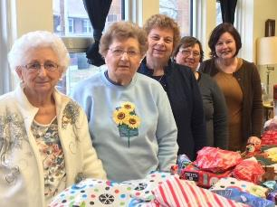 Marianne Graczyk, Rosemary Hulsman, Deb Beozzo, Rose Ann Colosimo, Kathy Reim

Rosemary Hulsman received the following note from Brenda. A big thank you for volunteering at POWER, each & every one of you made my stay at POWER special… I arrived at POWER just before Christmas. I was very upset that I would not be spending the holidays with my family. But thanks to each & every one of you It was a very special Christmas for me. To see firsthand that so many people cared about us ladies it was simply amazing. Thank you for showing us that we are worthwhile women!!! It was so nice to see just how many people care. PS 13 MONTHS CLEAN on 12/9/18.



P1

P.1

P1

**Multichapter History**

**Theta**

Our DKG journey began 71 years ago, on February 15, 1947, when six elite women formed the Theta Chapter. Laura Braun was our first president and encouraged eighteen additional strong-willed women to promote growth of women educators and excellence in education. Twenty-four women were the cornerstone of our chapter. We presently have 76 members.

Annually we provide five $1,000 scholarships

To aid Outstanding Women Educators in

pursuing academic study. We also provide one

$1,000 scholarship to stimulate the personal

and professional growth of members, and to

encourage their participation in programs.

Our project is POWER: Pennsylvania Organization for Women in Early Recovery. POWER’s mission is to help women reclaim their lives from the disease of addiction to alcohol and other drugs, and to reduce the incidence of addiction in future generations. Our members have supported 25 women who spend six months living in the Power House. Every September we have a POWER Wrap. Our members donate items to create bags which are given to the women at Christmas. We encourage literacy by donating books for the Children’s Library. We have supported POWER for 26 years.

At this meeting we were recognized as one of the Mother Chapters of Delta Kappa Gamma.



**November 17 Multichapter Meeting**

On November 17, Theta, Upsilon, Alpha Phi, Alpha Upsilon, and Alpha Xi honored our State President Barbara Gasperini. Barbara shared her journey visiting chapters and admired the hard work our wonderful ladies have done as Delta Kappa members through chapter projects. Her project Girl Scouts of America was selected as an organizatin who encourages strong leadership skills. Fellowship is an important part of maintaining a healthy Chapter. Sharing informatin and meeting new sisters was an important part of the Multichapter meeting.

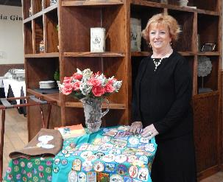

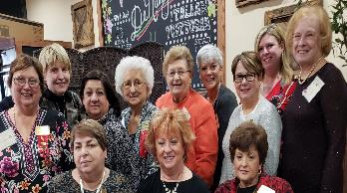

1st row Barbara Schnurr, Barbara Gasperini, Mary Grace Prata

2nd Row Rose Ann Colosimo, Michaileen Vilsack, Terri Magnotta, Marianne Graczyk, Rosemary Hulsman, Nancy Kodman, Linda Konczal-Evans, Tabitha Geramita, Madeline Carson

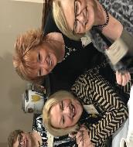

**Alpha Phi**

The Alpha Phi Chapter of DKG State organization is a vibrant and active chapter in southwestern Pennsylvania. We are forth-five members strong having just inducted one new member and accepted four new transfer members from two different disbanded chapters.

We serve our communities through six charity projects addressing the needs of children and families in our region such as Blessings in a Backpack, Layettes of Love for Magee Hospital in Pittsburgh, food banks, Little Libraries and support of Bright Beginnings, a nursery school in our area.

Our chapter has many interesting and diverse programs presented at our chapter meetings. In addition, we conduct several social events throughout year for our members. We are proud to state that we have supported the projects of our last three state presidents including the Chairs, the Little Libraries and now Barb Gasperini’s Girl Scout activities. Congratulations Madam President, Barbara Gasperini on this momentous occasion.

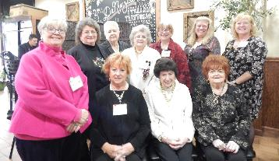

**Upsilon**

Upsilon Chapter has a current membership of 35 key women educators. At a recent meeting, we had our Grant-In-Aid Auction which provides funds for our Future-Teacher Scholarship of $1,000. We award this money annually to an Education Major who has reached “Junior Status” at her college/university. Supporting future educators is an annual Upsilon tradition dating back to our founding in 1947.

Another project which Upsilon Chapter actively supports is “Story Hour” at the Jeannette Public Library. An Upsilon member (and retired elementary teacher) runs the program. Head Start classes come to the Library for stories and make and-take activities. Raffles at Upsilon meetings provide the funds we donate to the Library for books and Story Hour activities.

Upsilon members have also helped preparing materials for Story Hour. This year, in addition to the regular Story Hour programs at the Library, Ms. Debbie will be doing an outreach Story Hour for a Head Start class which cannot travel to the Library.

Upsilon has taken on the PA State Girl Scout Patch project with one Junior Girl Scout troop. We are hoping two other troops will get involved early next year.

Upsilon Chapter has a social side too. Our Serendipity Book Club usually meets on the third Monday of the month at a restaurant in the area where we dine and discuss the book-of-the-month. New members are always welcome. Our winery outings planned several times during the year—have become legendary. Upsilon members come from: Burrell SD, Greensburg-Salem SD, Jeannette SD, La Roche College, Kiski Area SD, Norwin SD, Penn State New Kensington, Penn Trafford SD, and University of Pittsburgh.

**Alpha Upsilon**

Alpha Upsilon Chapter was organized in April of 1961 with nineteen charter members. Amelia Cooch was the first chapter president. Our members come from Westmoreland and Allegheny Counties and are strongest asset.

Through the years, our members remain unified in purpose and commitment to education and our communities. Each year, our chapter gives a Grant-in-Aid of $1000 to a graduating senior majoring in education. We also support the local Food Bank, the Hope Center, local libraries and the DKG Girl Scout project.

Alpha Upsilon’s commitment to the purposes of DKG is paramount on both the Chapter and State level. Currently Barbara Summers serves as our chapter president and Barbara Gasperini serves as president of the Pennsylvania State Organization. Carolyn Sutton also served as state president and currently serves as parliamentarian for the chapter and the state.

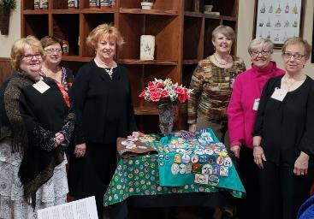

Chapter Presidents

Faith Jack-Alpha Xi, Rose Ann Colosimo-Theta,

Barbara Gasperini-State President and Alpha Upsilon, Barbara Summers-Alpha Upsilon, Maryann Battaglia-Alpha Phi, Patti Marco-Upsilon

**Alpha Xi**

Alpha Xi, founded December 8, 1956, is the North Hills area chapter. Present districts represented are: Avonworth, North Allegheny, North Hills and Shaler Area.

Our first Presidents were: Miss Ethel G. Coughlin 1956-1960, Miss Virginia Hannan 1960-1962, and Miss Thalia Bock 1962-1964. The 2018-2020 officers are: Faith Jack, President; Terry Klein and Debbie Steinmetz, Co-First V. Presidents; Sandy Werderitch, Second V. President; Shari McGill, Recording Secretary; Darlene Farrell, Corresponding Secretary; and Marg Foster, Treasurer.

Our 44 Alpha Xi members enjoy six meetings each year with wonderful programs ranging from after-hours tours of the Heinz History Center, hands-on crafting at the Pittsburgh Glass Center, planting a mini-succulent terrarium, to slide presentations of local history such as the Great Castle Shannon Bank Robbery and Pittsburgh Then and Now.

Service Projects have been many through the years, but our long-standing project has been the Jared Box Project for Children’s Hospital. We decorate and fill 30-40 plastic shoe boxes with small toys, books, art supplies, activity books and a personal note from an Alpha Xi sister wishing the recipients well and hoping the box helps to pass their time in the hospital.

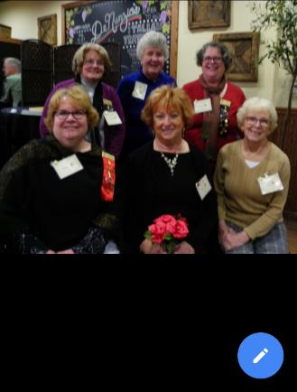



**Theta Cares**

What a beautiful way to remember a loved one or special person by sending a memorial or special tribute! Monies from this are contributed to Theta’s Recruitment Grant Fund. Send checks to Andrea Ventomiller, 407 Bryant Drive, Pittsburgh, PA 15235.

**Scholarships**

Please contact Patti Illig if you know of a female Junior or Senior major in education who may qualify for a scholarship. All applications and information are due by January 30.

Please contact Deb Beozzo for scholarship

chapter members in good standing. To

stimulate the personal and professional growth

of members, and to encourage their

participation in programs. The applications

are also Due January 30.

**Important Dates to Remember**

**PFT Helping Hands for the Benefit:**

February 21, 2019

**Creative Arts Retreat:** March 28-30, 2019

**Nevillewood Country Club, Benefit:**

**GAMES PEOPLE PLAY!**

Saturday, April 6, 2019

**Founders Day: South Hills Country Club:**

May 18, 2019

**Pensylvania State Convention:** June 14,15,16, 2019 Nittany Lion Inn State College, PA

**Northeast Regional Conference, Mashantucket, CT:** July 30- August 1, 2019

**DKG Oath**

On my honor, I will try,

to serve God and my country,

to help people at all times,

to live by the Girl scout law

to encourage women educators

and to promoting professional and personal growth for woman worldwide.

**Holiday Social**

